SiteWorks - Plugin Update Server

The service is provided using the WP Update Server software from https://github.com/YahnisElsts/wp-update-server

Installation
The software is installed on the main SiteWorks website in a subfolder of the web document root:
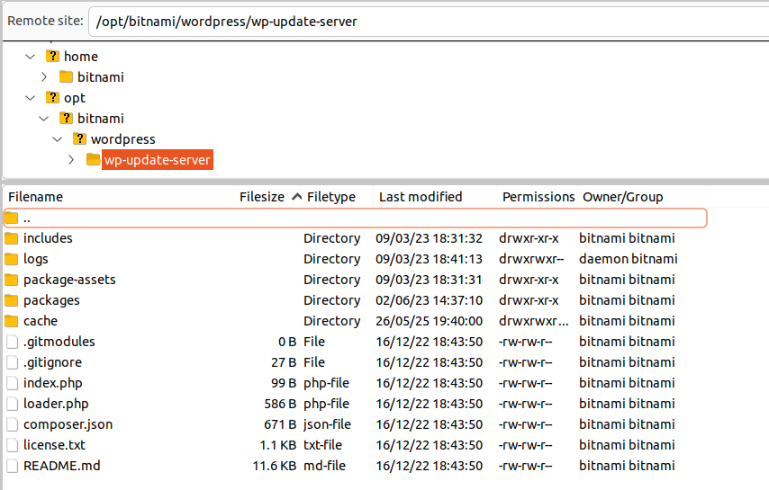
Installation is just a matter of unpacking the zip file from the GitHub repository, renaming the top folder from wp-update-server-master to
wp-update-server

To allow the webserver to update the log files, the logs folder and contents need to be owned by ‘daemon’.

Updating SiteWorks plugins
The plugin zip files are stored in the packages folder. To update a plugin file just replace the current plugin file. The software will deal with the change automatically.

Package assets
Each plugin requires two image files to be created and saved in the
package-assets/banners folder.
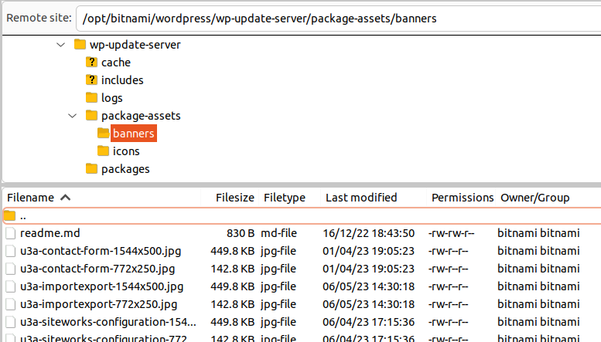
These image files are used by WordPress when creating the Show details panel for each plugin in the WordPress Dashboard. There is no need to change these unless a plugin name is changed which would require an updated image.

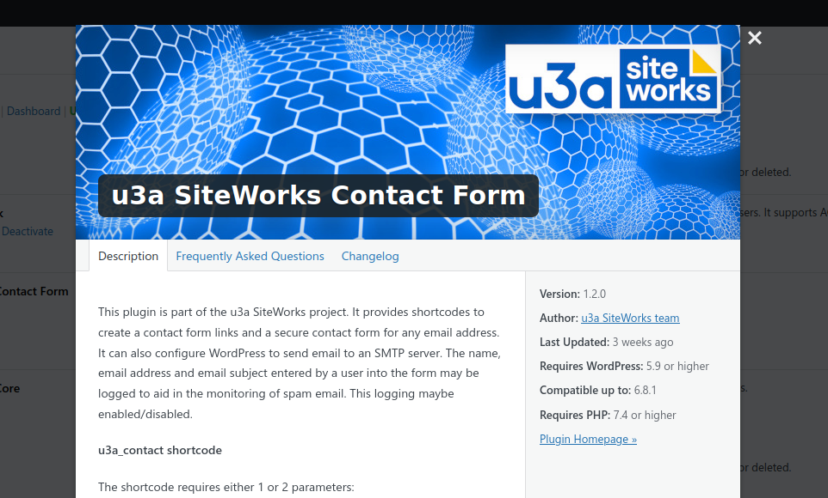
From image file
From plugin’s
readme.txt file

Update Server Log Files
Each time a WordPress installation queries the update server a log entry is added to the request.log file in the logs folder.
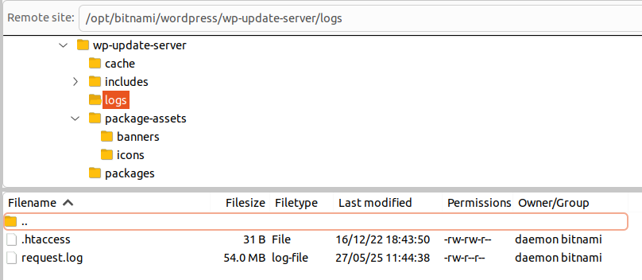
The log is in plain text and includes time and date, URL of the WordPress installation checking for updates and which plugin was being checked.

Clearing the log file
From time to time the log file needs to be cleared. It may be useful to make a local copy before doing so.
Console command to clear log file:
cd /opt/bitnami/wordpress/wp-update-server/logs
sudo truncate -s 0 request.log

